CONFIGURATION PROYECT PROTOTIPOCOSTOS

Software necessary
- Eclipse Keppler
- GlassFish 4
- JDK 1.7.0
- Postgres
- Plug-in SVN in eclipse or TortoiseSVN

Download source the project

From Eclipse
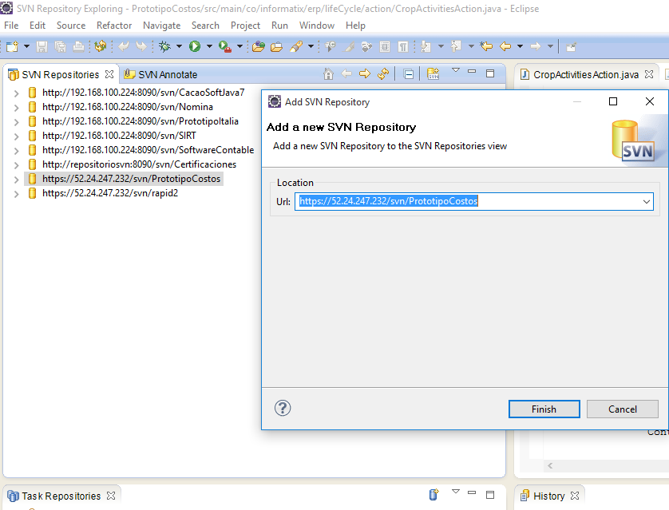

From TortoiseSVN
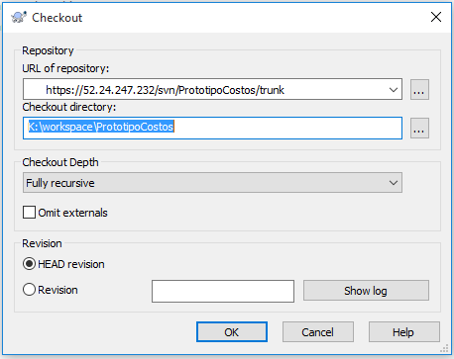

Import the project in Eclipse
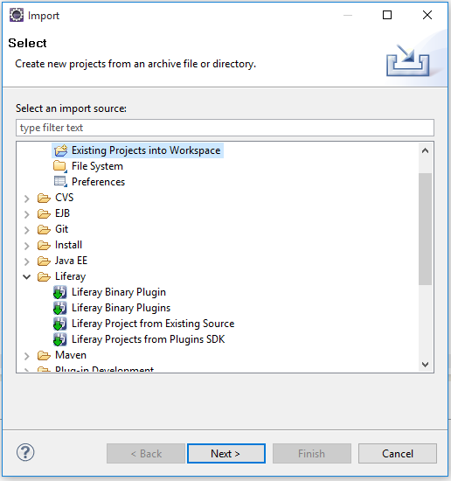

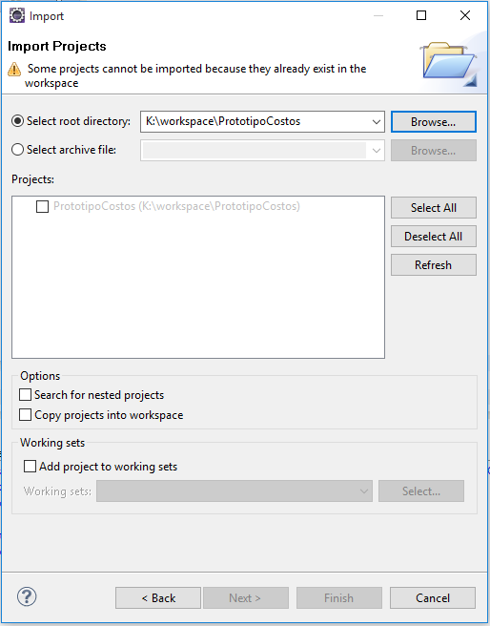

Configuration the data base
- The installers for Postgres
- Execute the scripts
- Configure the path the data base in the files:
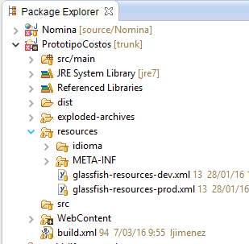

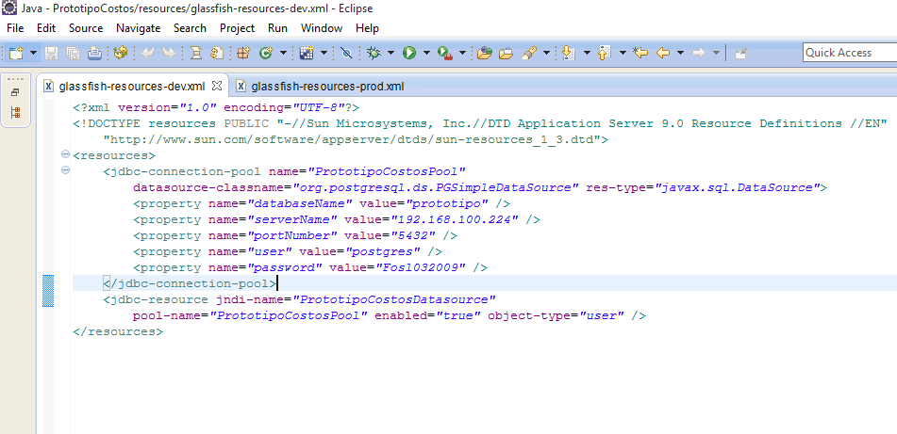

Configure the Server
- Unzip glassfish local disk K
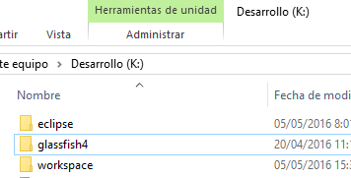

- The server is located in the folder the repository called software.
- Add New Server in Eclipse:

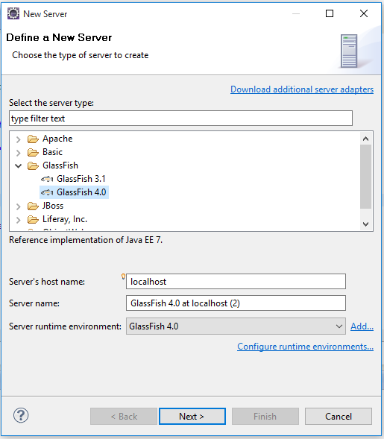

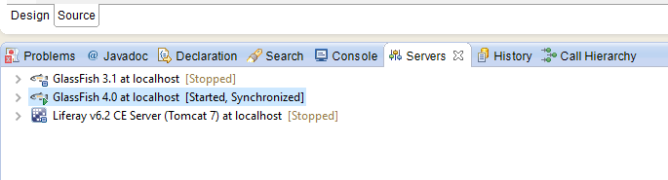

Steps for build the project
- Configurate paths of the file PrototipoCostos.properties is in: K:\workspace\ PrototipoCostos\WebContent\WEB-INF\classes, change work environment paths:

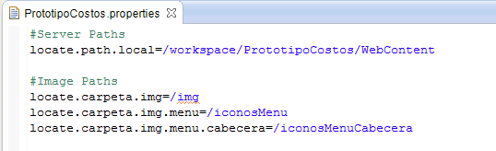

- Start the server
- Execute the Ant
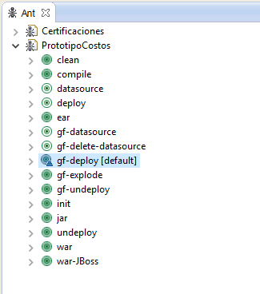

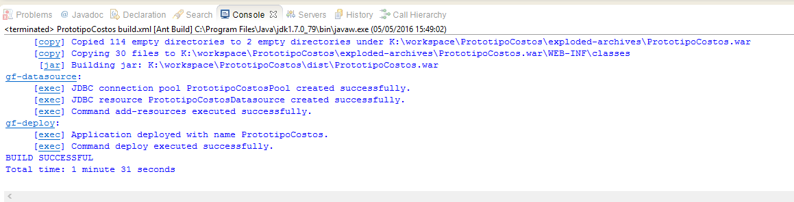

- Load the page http://localhost:8080/PrototipoCostos
